3x3 Observations: December 2009
SPECIAL EDUCATION Department – 7 Classes

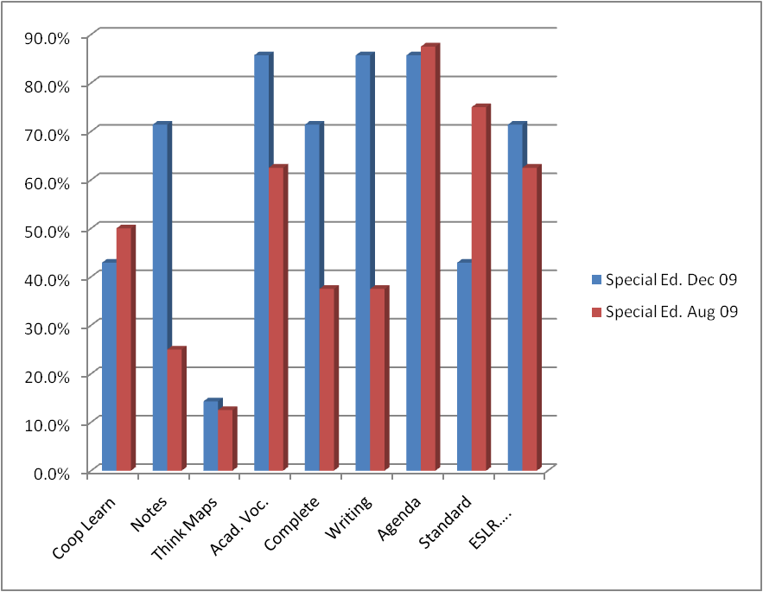

Special Education | Coop Learn | Notes | Think Maps | Acad. Voc. | Complete Sentences | Writing | Agenda | Standard | ESLR….
Dec 09 | 42.9% | 71.4% | 14.3% | 85.7% | 71.4% | 85.7% | 85.7% | 42.9% | 71.4%
Aug 09 | 50.0% | 25.0% | 12.5% | 62.5% | 37.5% | 37.5% | 87.5% | 75.0% | 62.5%

